AUSTRALIA AT WAR

September 1939, Australia’s duty – victory would be costly.

A fear of Japan.

Two elements to Australia’s defence forces: 6th, 7th & 9th; the 8th

Militia

Phase One: North Africa, Greece & Crete, Syria, Tobruk, El Alamein
The Royal Australian Navy ; Royal Australian Air Force

Australia had committed its best forces - would be reciprocal

Phase Two: December 1941, Pearl Harbor, Philippines,
Hong Kong, the ‘impenetrable’ Malay jungle

15 Feb Singapore, the Bastion to the British Empire surrendered.

India & Australia exposed to invasion.

A massive change in Australian foreign policy: ‘Australia looks to America’,

19 Feb 1942, Darwin was bombed

Dutch East Indies

Churchill and the Australian 7th Division

The Battle of the Coral Sea

Battle of the Kokoda Trail.

June 1942 Japanese midget submarines

The threat of invasion frighteningly real. Curtin’s use

A US base/ crucial security

The Brisbane Line

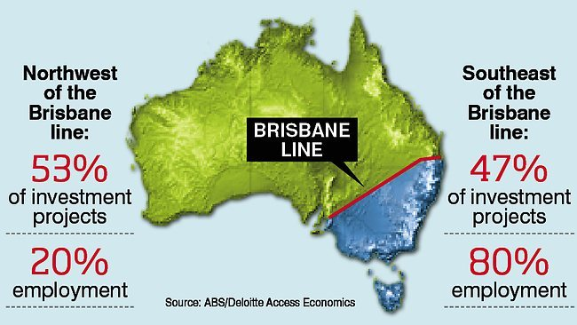

US priorities; MacArthur’s ambition - censorship & publicity

Once the Japanese were routed and defeated in Papua, Australia was out of danger - prestige & influence in the region would be in proportion to its contribution.

HOME FRONT
On the outbreak of war, September 1939, Menzies headed a minority UAP Government.
Lost 3 trusted ministers in air crash; positions filled by 3 Country Party members.

Sept 1940 election, balance held by 2 independents –

An all-party advisory council. Labor used this to influence wider social welfare.

Early in 1941, Menzies travelled to Britain regarding Singapore

By August 1941, Menzies forced to resign.
Fadden took over, losing support of the 2 independents. Labor became the new government under Curtin.

The first 2 years of war saw an unprecedented growth in Commonwealth powers, intended to be temporary

The National Security Act, 1939 –Federal (Commonwealth) Government wide powers to make new laws– Australia became a government by regulation:
- 400 acts or amendments by Parliament
- 2000 regulations by the Council

The internment of ‘aliens’,
Goods essential for the war effort could be demanded from any factory, forcing people to place themselves, their services & property at the government’s disposal.

Murdoch, Director-General of Information and wide powers of censorship

Bans placed on public meetings; price controls placed on certain commodities. Clothing, meat, tea, butter, and sugar were rationed.

Clothing restrictions.

Taxes increased and the government took complete and total control of all shipping.

The Jehovah’s Witnesses declared illegal
The Communist Party was banned, but reinstated in 1942
Wartime banking control regulations introduced

An Austerity campaign to encourage less spending

In 1942 ID Cards were introduced.

Reduction of holiday periods, daylight saving was introduced and restrictions on sporting events, restaurant opening times and drinking hours.

Controls increased government spending; hundreds of boards were set up to implement public services. Civil servant numbers increased from 30,000 in 1940 to 1000,000 by 1943.

With the threat of invasion came blackouts, evacuation plans and barbed wire beaches. The Volunteer Defence Corps was formed holding 95,000 members by 1942. There were drills, sirens, shelters being dug, camouflaged public transport and reinforcing of buildings.

Home defence enthusiasm waned as the risk of attack seemed to pass, but anti-Japanese propaganda was rife (and racist) cultivating a hatred of the Japanese, more so than Fascism.

Britain had agreed to buy the entire export surplus of Australian wool for the duration of the war. Huge number of US troops gave an added market to Australian produce.

Almost 250,000 American troops were stationed in Australia to a warm reception. They were welcomed as a safeguard, but their presence caused considerable resentment. The average

US soldier earned 17 pounds a month, double of that of the Aussie troops: their spending power pushed up local prices, encouraging a black market. US troops were seen to get the best service from shopkeepers and taxi drivers. American men attracted the women too - 10,000 Australian women left to live in the US by the end of the war.

There were riots in Brisbane between US & Australian troops during 1943: two nights of rampage with bottles, bricks, guns and fists. The press was suppressed from making any reports.

African-American troops were highly segregated; often clubs & hotels refused their service. Australia was still largely a racist society. Many ‘black’ US soldiers were sent to outback locations, building airfields and roads.

Fertiliser use in agriculture, and to a certain degree production, declined during the war due to a scarcity of superphosphate as Nauru had become occupied by the Japanese. A serious drought during 1944 reduced production further. Rubber tyres too were almost unobtainable due to the source of supply lost to Japanese expansion.

Many skilled farmhands had left the land during the Depression; they enlisted during the war or took jobs in the expanding manufacturing industries.

The war led to growth & diversification of Australia’s industries as there was a need to manufacture home grown war materials. The lack of transportation led to problems with distribution.

The growth of basic industries during the inter war years had allowed an effective industrial expansion during the war. The war brought employment back for many after a decade of unemployment.

War did not eliminate industrial dispute; there were continued stoppages on some NSW Coalfields. By March 1942 government regulations meant that those who went on strike could be called up to go to war.

By 1943 it became increasingly clear that the war would be won. There became a gradual reduction in the numbers needed in the armed forces. Late in that year blackouts became no longer compulsory. People became less willing to accept the government controls.

In 1944 Curtin wanted extended powers to last another five years to oversee a reconstruction period to create more equality after a period of sacrifice. His aim was to achieve higher employment and better living standards. The non-Labor State government did not grant Curtin’s change to the constitution, which was lost in a referendum during 1944. Most Australians had come to resent the hundreds of wartime controls that had affected almost every aspect of their day to day lives.

A political legacy of the war was that people began to accept Commonwealth power and control over the State governments. There had also been a decreased interstate rivalry which had contributed to sense of nationalism.

